 

Avalara Tax Sitecore Commerce Plugin

AvaTax Plugin User Guide

Version: 2.0

**Prepared by:** XCentium

**Project Manager**: Balaji Thirumeninathan

**Date Created**: October 4, 2019

**Date Last Modified**: October 4, 2019

**Document Purpose**

The purpose of this document is to provide content authors with an insight on configuring Avalara Tax Plugin and related commerce content

**Document Approvers**

|  |  |  |
| --- | --- | --- |
| **Name** | **Project Role** | **Approval Date & Method** |
|  |  |  |
|  |  |  |
|  |  |  |
|  |  |  |

**Document Contributors**

|  |  |
| --- | --- |
| **Name** | **Project Role** |
|  |  |
|  |  |
|  |  |
|  |  |

**Version History**

|  |  |  |  |
| --- | --- | --- | --- |
| **Version #** | **Revision Date** | **Revised By** | **Change Descriptions** |
| 1.0 | 4/1/2019 | Balaji & Ola | Document created |
| 2.0 | 10/4/2019 | Balaji & Ola | 9.1.1 Release |
|  |  |  |  |
|  |  |  |  |

**Version History – Post Approval**

|  |  |  |  |  |
| --- | --- | --- | --- | --- |
| **Version #** | **CC#** | **Revision Date** | **Revised By** | **Change Descriptions** |
|  |  |  |  |  |
|  |  |  |  |  |

**Glossary of Terms**

|  |  |
| --- | --- |
| **Term/Acronym** | **Definition** |
| CMS | Content Management System |
| Sitecore | Web Content Management System |
| Item | Items are the basic building blocks of your Sitecore website |

Table of Contents

2 How to Setup Tax Code 3

3 Product Setup 3

4 Product Variant Setup 4

5 Tax Excempt Customer Setup – Entity Use Code 5

# How to Setup Tax Code

1. Using the Biz Tool under Launch Pad, Navigate to a Sellable Item or its variant and you will see a view with a form field that allows you to add your Avalara tax code [See figure 4.0 and 5.0 on this document](https://github.com/XCentium/SC-Plugin-Tax-Avalara/blob/SXC902/docs/AvalaraSetupReference.docx).
2. Go ahead add tax code to all your products and variants.
3. Where a product or variant does not have a tax code, a taxcode of "P000000" is assumed
4. You can also navigate to a customer using BizToool and set Entity Use Code or Exemption Number for that customer incase the customer is an institution exempted from being taxed [See figure 6.0 on this document](https://github.com/XCentium/SC-Plugin-Tax-Avalara/blob/SXC902/docs/AvalaraSetupReference.docx).

**Note:**

1. Remember to register with AVALARA and get your API connection details. Also activate your registration and set your AVALARA Nexus choices.
2. If you have any questions, comment or need us to help install, extend or adapt to your needs, do not hesitate to reach out to us at XCentium and ask about the Sitecore Commerce Engine AVALARA Plugin.

# Product Setup

Figure 4.0

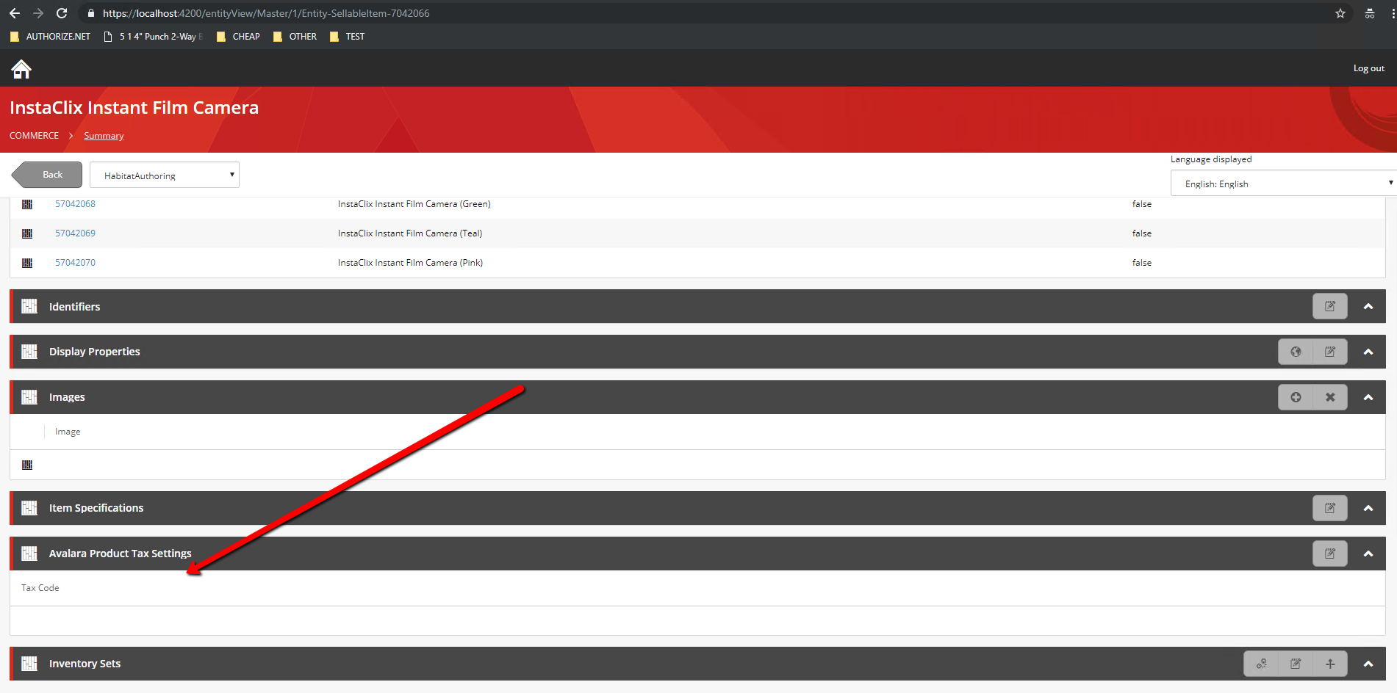

# Product Variant Setup

Figure 5.0

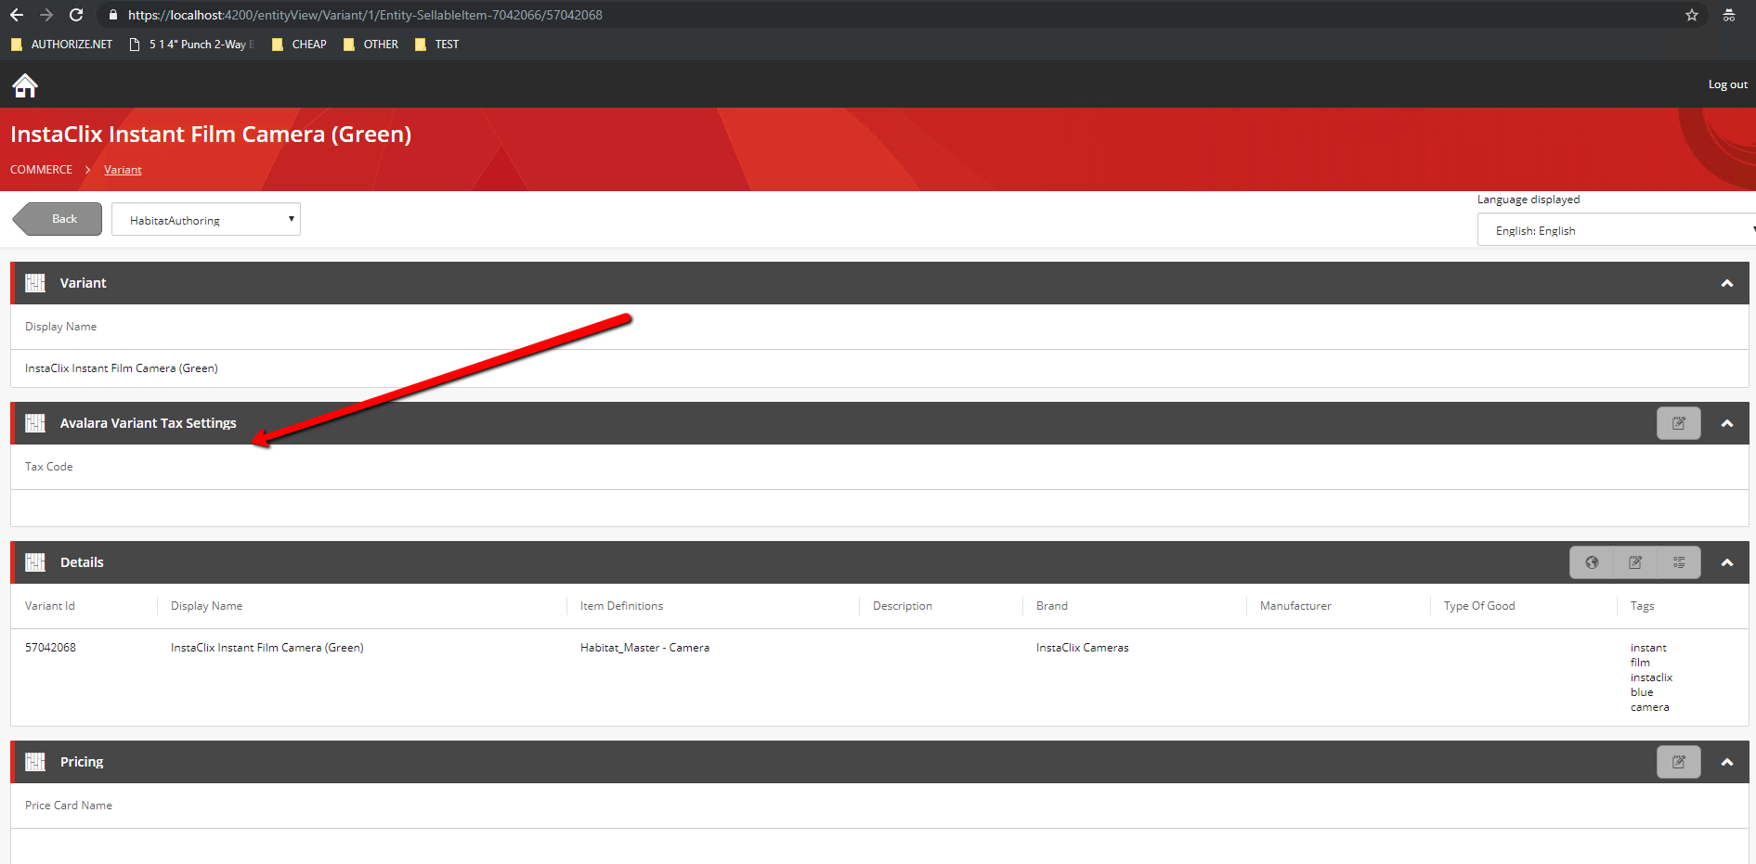

# Tax Excempt Customer Setup – Entity Use Code

Figure 6.0

